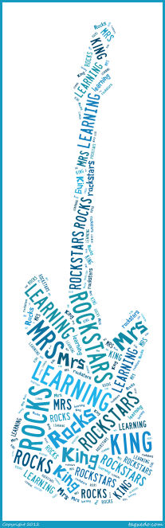
Mrs. King’s 2nd grade
Welcome to 2nd grade! Following are some of my expectations and how the 2k class runs. My door is always open to parents, any questions please feel free to email me: jking@scbss.org or call me at the school 766-2128 ext 2012.

Homework
Homework will be assigned Monday through Thursday. A typical day of homework would be a spelling activity, a Math page and either a Language or Phonics page. Homework is required to be completed and turned in the following morning. In addition to written homework, students are expected to read for at least 20 minutes each evening; there is no log required to turn in.

Monthly Book Reports
Each month students are required to complete a book report form on a book read that month. I would ask that parents read with their child and help them throughout the process. The main goal of this assignment is for practicing strategies learned in class and developing a love of reading.
Reports are due on the last school day of the month but may be turned in at any time throughout the month. Book report forms to be printed out can be found on our class website (www.2krocks.weebly.com), under the Parent Resources and the Homework sections. Hard copies are available from Mrs. King upon request. For more information on the reports see the assignment sheet in your student’s ROYAL.

ROYAL- Family Involvement Starts Here
Each student has a ROYAL (Responsibly Organizing Your Awesome Learning) notebook which is an organizational and communication tool. The ROYAL notebook is to be brought home every night and brought back every morning. Please be sure to check your child’s ROYAL notebook nightly for any and all important papers.

Behavior
During this year it is one of my goals to teach your child how to self-reflect, and be truly honest when self-reflecting. With this in mind, I have a “weekly reflection” sheet that is kept in the ROYAL. Each day your child will assess themselves at the end of the day; I will initial below each day as I briefly conference with each student. During the first few weeks (if not month) of school I will be guiding your child through this process so that they are aware at what is expected. Along with the self-reflection I plan on implementing the “Clip Chart simple discipline strategy for promoting positive behavior” created by Rick Morris. For more on the “Clip Chart simple discipline strategy for promoting positive behavior strategy” feel free to go to: http://www.newmanagement.com/ebooks/pdf/clip_chart_ebook.pdf
Any major discipline problems or minor class disturbances will result in a lunch detention, and visit to the disciplinarian. If your child is sent to the disciplinarian a disciplinary report form from the school office will be sent home.
Snack/Lunch
We will be having snack around 9:00 each morning, please send a NUTRITOUS snack, children may bring water. Recess will be from 11:40-12. After recess, we will be eating lunch in our classroom from 12:00pm- 12:20pm. We ask that you please pack a mat in their lunches to aid with cleanliness of their food and the classroom. Any lunch monitor help would be great!
Birthdays
Birthdays are special! Students receive a “tag day” for their birthday and parents are welcome to provide a special treat for their child to share with the class and celebrate his/her birthday.
Tests
I will be testing your child at the end of each unit in every subject. All of the tests will be announced ahead of time except for Reading and Math tests. I do not announce these tests because it shows me really how well each child understands the material up to that point. It is crucial that the children have full understanding of these subjects before moving up to the third grade. I use a variety of assessment tools which include: Traditional tests, project-based learning assessments, checklists, rubrics and anecdotal observations. I also give many “what do you know” assessments, these are not graded and are used as a guide for me, as they give me an insight into where the class’ knowledge level begins on specific concepts. I also conduct a thorough reading level assessment three times a year. It is very important that they pay close attention in class, complete their classwork and their homework each night.
Specials/Schedule
The specials and schedule are listed on a separate sheet, and kept in your child’s ROYAL in a clear protective sheet for you to reference as needed.
Mass
Mass is Thursdays @ 8:40 am, unless otherwise noted.

